1.4. Switching to Another Computer
You can use the software on another computer by adding your current computer to our blacklist associated with your license key. You will not be able to activate GMDH Streamline on your current computer unless you have a new license key.
In the menu click Help > Move to another computer:
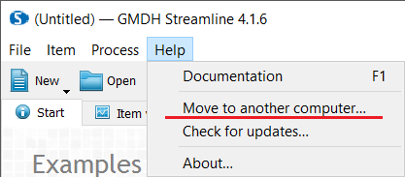
Enter your license key as confirmation:
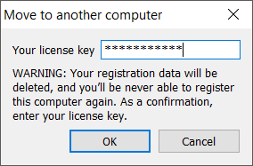
Click OK to complete the deactivation process. The deactivated copy of GMDH Streamline will revert to the demo version of the software.
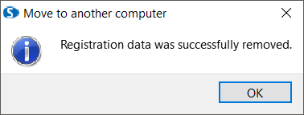
Now you can activate Streamline on a different computer.

Next: Using Streamline on a Mac
Download PDF
Tracedump:
newBaseSize: 16pt
newBaseSizeInPt: 16

