7.2. Forecast Approval System
Streamline has a forecast approval system that helps you to set which forecasts have been reviewed and approved, and which need further attention. The approval system allows users to authorize or place emphasis on generated forecasts.
You can assign one of three statuses to any node of the tree in the Tree view. They are:
- Approved status.
- Needs attention status.
- Undecided status.
Any nonleaf node of the tree has an additional Blank status. This status is set by default (see figure below).
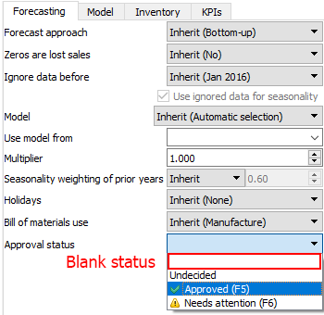
It means that there can be any mixed approval statuses under the selected node. It is used when you need to leave all the descendent nodes’ statuses as they are.

Approved Status
Approved status is typically set when the forecast for an item looks good.
To set the Approved status to an item:
- Select the item in the Tree View.
- Click on the Approve/Unapprove button or set the item approval status to Approved in the Forecasting tab (see figure below).
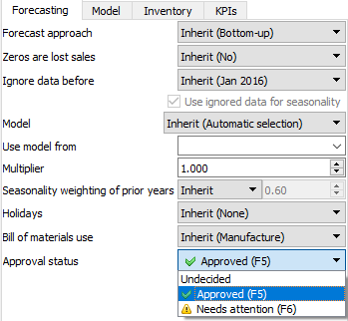
All of the Forecasting settings can be applied at every level of the tree. A green checkmark in the Tree view indicates that the Approved status has been applied (see figure below).
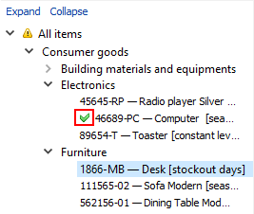
Besides the visual indication in the Tree view, the Approved status for a node also means that:
- The forecasting model is locked. That is, the forecasts will not be changed even if you pause&unpause auto-forecasting.
- All the forecasting settings for the node are locked. That is, inherited forecasting options from parent nodes will not be applied to this node.
The described locking mechanism is designed to freeze the state of the final demand forecast for the time while different company’s departments (sales, financial, marketing, etc.) are approving them.

Needs Attention Status
If you are not sure which forecast correction to make currently (whether it is changing the model type or any other) and have decided to make the correction later, you can set the approval status to Needs attention as a reminder. Then an attention icon is added to the node and all the nodes above it to easily spot these items if the tree is collapsed (see figure below).
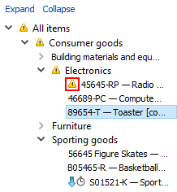
This status makes only a visual effect in the Tree view, it does not put any restricts or locks on the forecasting models.

Undecided Status
Undecided status is the default status for leaf nodes of the tree. This status is typically used to:
- unapprove the forecast of the selected node at the leaf level (alternatively, you can use the Approve/Unapprove button of the toolbar);
- drop the approval status of the selected node (nonleaf level) and all the descendants to the defaults.

Next: Safety Stock Calculation
Download PDF
Tracedump:
newBaseSize: 16pt
newBaseSizeInPt: 16

