7.11.1 Filter Dialog
Filter dialog is used to configure filtering expression for a custom report. Streamline is able to build very powerful filtering expressions. You can filter by any column of the All items report and use several options in one filtering statement. You can build compound expressions having up to twelve filtering statements.
You can create custom reports on the Inventory planning, Inter-store optimization, Distribution center, or Report tab. Depending on the tab, the set of columns used in filtering expressions differs.
To open the Filter dialog:
- Go to one of the mentioned tabs.
- Click the New filter button found on the left of the All items tab (see figure below).
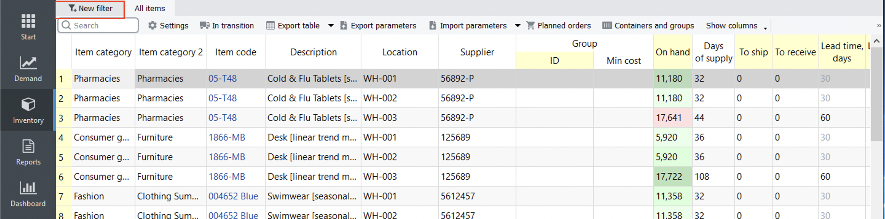

Description of the Dialog
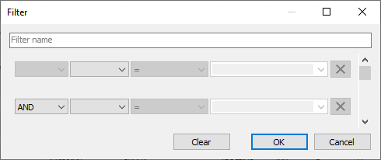
- The Text field at the top of the dialog is used to name the filter/report. This name will be displayed in the title of the newly created tab (see figure below).
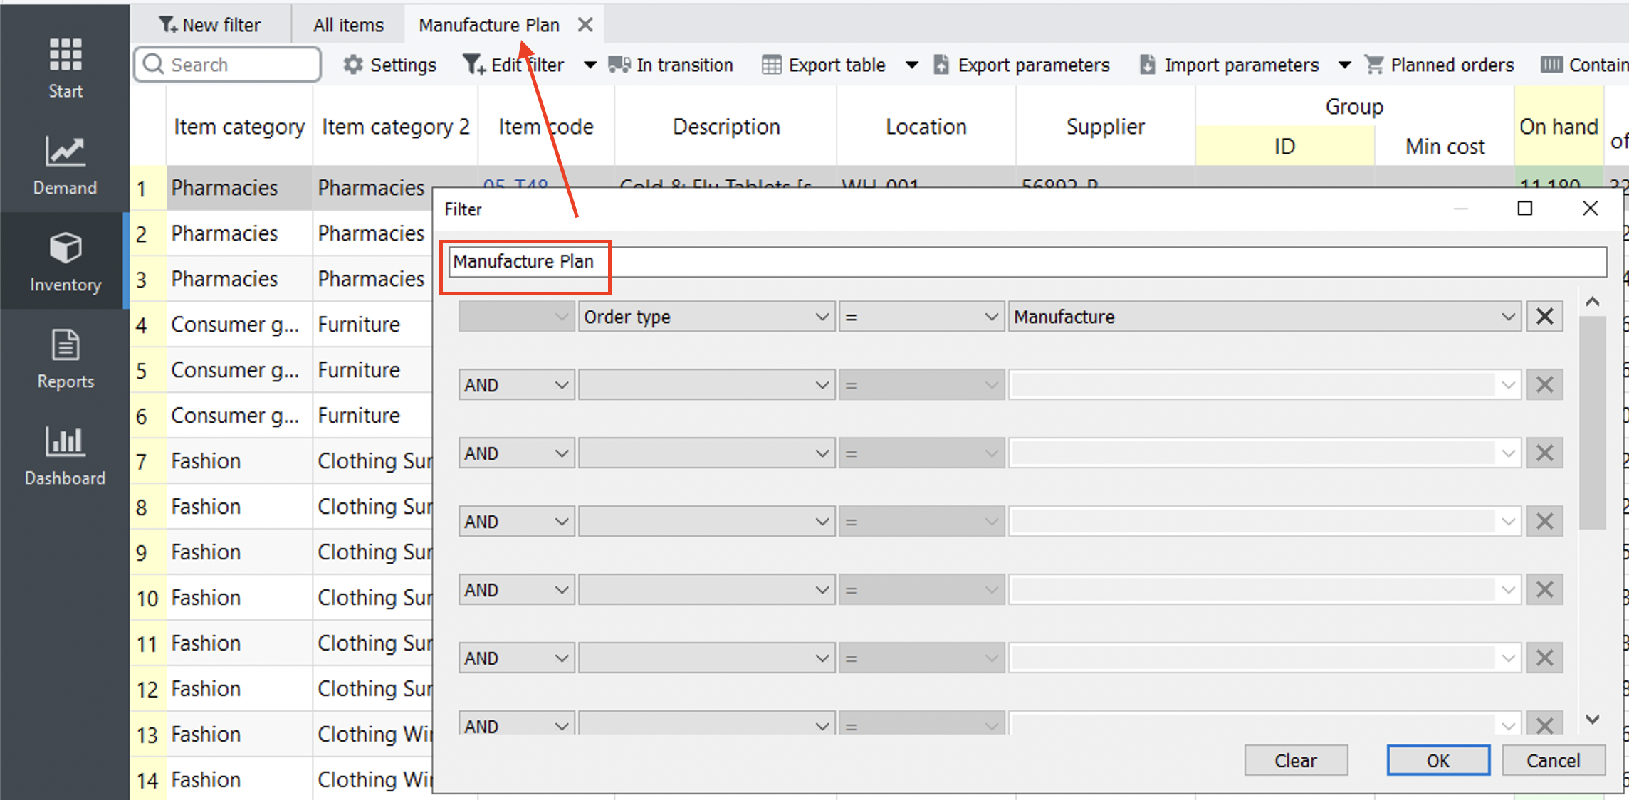giving_a_filter_name
- Lines of controls below the Text field is used to build a filtering expression.
- The Clear button clears the filtering expression.

Filtering expression
A filter or filtering expression is built from elementary statements and structural operators. For example:
(A OR B) AND C.
Here:
- A, B, and C -- elementary statements that can be false or true;
- logical operators OR and AND, and brackets “(”, “)” -- structural operators that build the structure of the expression.
By-turn, elementary statements follow the syntax:
<column name><relational operator><value>.
The figure below shows the mentioned parts in the Filter dialog.
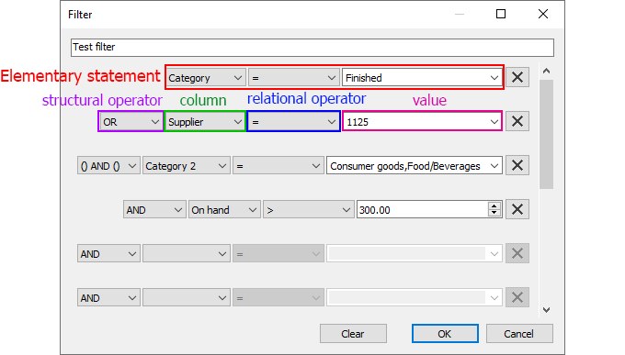

Structural operators
Streamline filters implement three structural operators. Two of them are logical operators AND, OR and the third one -- a brackets operator () AND ().
Each line below the Filter name field is used to build an elementary statement. The X button at the end of each line clears the corresponding condition.
Let's consider examples.

AND Operator
The filter shown in the figure below is equivalent to the expression:
Item code = 11 AND Item code = 22 AND Item code = 33
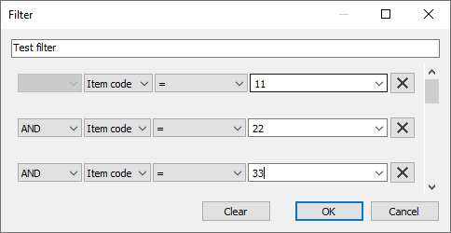

OR Operator
OR operator is always applied after AND operator. Consider an example shown in the figure below.
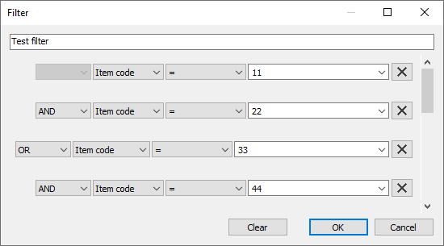
The equivalent statement is:
Item code = 11 AND Item code = 22 OR Item code = 33 AND Item code = 44
As you see, Streamline groups statements that will be applied first using indents. Intends here are equivalent to brackets. So, this filter can be also written as:
(Item code = 11 AND Item code = 22) OR (Item code = 33 AND Item code = 44)

'() AND ()' Operator
This is a brackets operator that is used to control the application order of AND and OR operators. For example, in order to write the following expression:
(Item code = 11 OR Item code = 22) AND Item code = 33,
you should build the filter represented in the figure below.
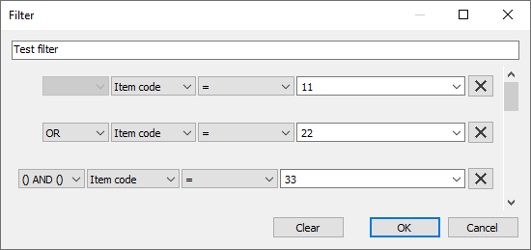
However, the brackets operator can be applied only at one level. It means that nested brackets are not supported currently. For example, you can't build filtering criteria for the following expression:
((A OR B) AND D) OR E.

Elementary statements
An elementary statement in Streamline has the following syntax:
<column name><relational operator><value>.
For example:
Item type = Material.
You can use any column of the All items report in each elementary statement. Streamline automatically loads and shows all the available values for the selected column of which you can select the required (see figure below).
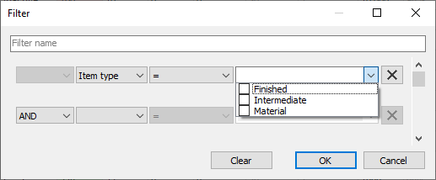
Depending on the column type (string or numeric) set of Streamline relational operators differs (see table below).
Column type | Operators | Description
String | = | Equals to
String | ≠ | Doesn't equal to
String | NULL | Is empty
String | ≠NULL | Is not empty
String | Contains | The column value contains the given phrase
String | Doesn't contain | The column value does not contain the given phrase
Numeric | = | Equals to
Numeric | ≠ | Doesn't equal to
Numeric | < | Less than
Numeric | ≤ | Equal or less than
Numeric | > | More than
Numeric | ≥ | Equal or more than
Numeric | NULL | Is empty
Numeric | ≠NULL | Is not empty
For string columns, you can give several values in a statement using comma “,”. This will be treated as a logical operator OR. For instance:
Item type = Finished,Intermediate.
If a value contains a comma, use quotation marks ““ to wrap the value. For example:
Description = Arm Boom,”Muesli box, 500 g”.

Next: In Transition Details Dialog
Download PDF
Tracedump:
newBaseSize: 16pt
newBaseSizeInPt: 16

